**LAB OEL**

**Option 1:**

We try to make database on Microsoft Azure but the issue we face was that we didn’t get the free trial to make database on Microsoft Azure so we moved forward to 2 option.

**Option 2:**

We make database on MongoDB but the issue we face was that the drivers was not supporting to connect the MongoDB database with SQL Management Studio So we moved forward to 3 option.

**Option 3:**

***CREATED TWO DATABASES***

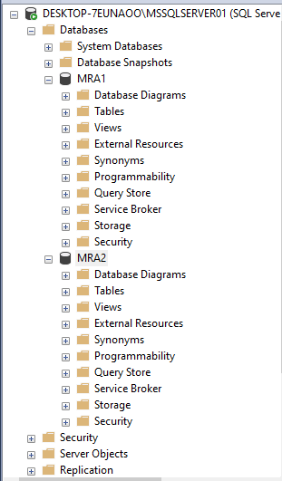

***INSERTED DATA IN BOTH DATABSES BY FOLLOWING QURIES.***

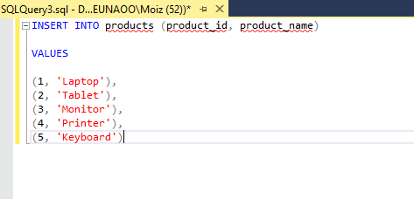

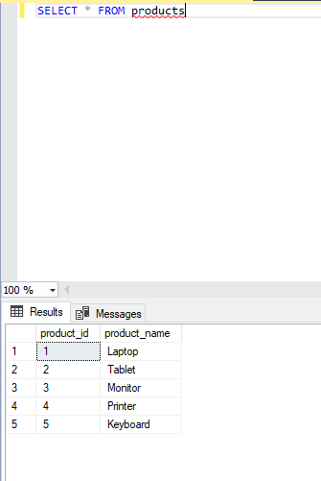

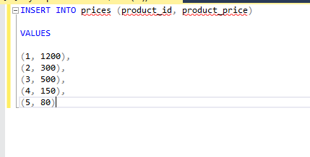

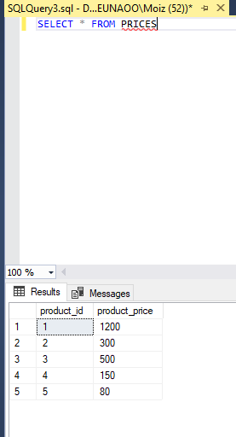

NOW JOINED THESE TWO DATABASES

